

SYNOPSIS ON

**WHATSAPP CLONE**

**SUBMITTED BY:- SUBMITTED TO:-**

Anushka Singh Rathore Md. Amir Khan

Branch : B.Tech (CSE) Technical Trainer,.

Section : K Department of C.E.A

Uni. Rollno : 191500143

**INTRODUCTION:**

We have developed an WhatsApp Clone. This contains the following features:-

* WhatsApp Web UI
* Create rooms or groups
* Sign in with Google account
* Last seen for groups
* Messaging boxes [green for own and white for the replies of others]
* Send message in group with timestamp

**EXISTING SYSTEM USE OF THE PROJECT:**

Messaging apps have become extremely popular! The latest messaging app

usage statistics show that WhatsApp has 2.0 billion users worldwide and

Facebook Messenger 1.3, while WeChat is just behind with 1.2 billion. What

are the trends in individual countries? What are the most popular apps? We

have put together an overview of messaging app usage statistics worldwide.

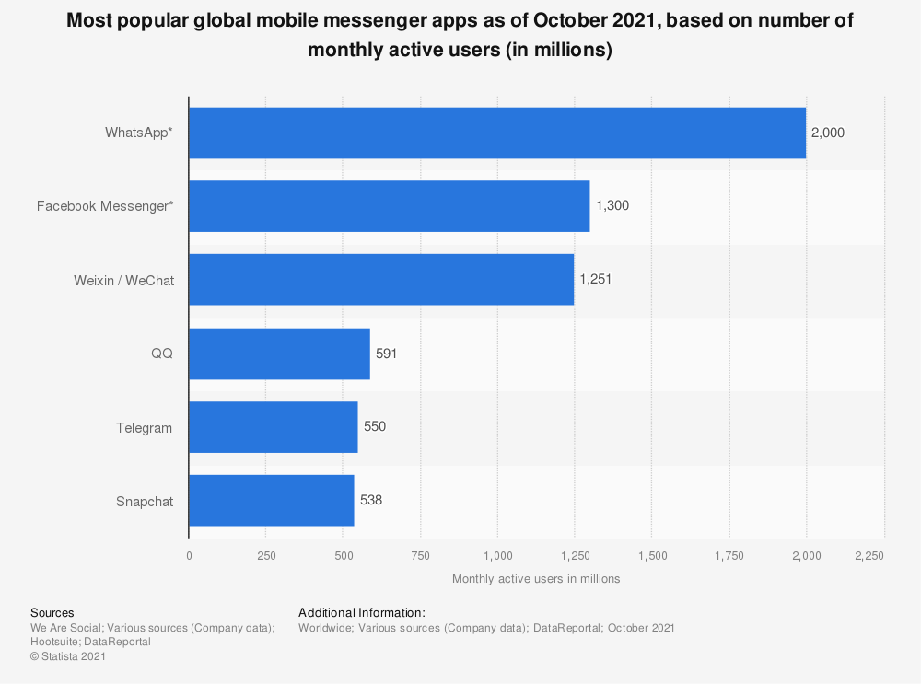

**Software Specification/ Functional Specification:**

* Software used: VSCode
* The language used : React
* Database: Firebase, MongoDb
* Visual Studio Code, also commonly referred to as VS Code, is a source-code editor made by Microsoft for Windows, Linux and macOS. Features include support for debugging, syntax highlighting, intelligent code completion, snippets, code refactoring, and embedded Git

**Github Link : <https://github.com/anushka-rathore2/WhatsAppClone.git>**

**Hardware Requirements:**

* Processor: Intel i5
* Android Application -WhatsApp Clone
* Operating System: Any Operating System
* RAM: 8 GB (or higher)
* Hard disk: 256GB

**Future Scope:**

This idea is very easy to implement as basic technologies are used and after

and base of various messaginng app.